Course ___Methods_Test 2_ Year __12_______

Student name: ________________ Teacher name: ________________

Date: 30 March

Task type: Response

Time allowed for this task: _____45______ mins

Number of questions: _____8______

Materials required: Calculator with CAS capability (to be provided by the student)

Standard items: Pens (blue/black preferred), pencils (including coloured), sharpener, correction fluid/tape, eraser, ruler, highlighters

Special items: Drawing instruments, templates, notes on one unfolded sheet of
A4 paper, and up to three calculators approved for use in the WACE examinations

Marks available: __46____ marks

Task weighting: __10__%

Formula sheet provided: Yes

Note: All part questions worth more than 2 marks require working to obtain full marks.

Q1 (3.2.1-3.2.3) (3 & 3 = 6 marks)
Determine in terms of for the following.
- given that when .

- given that when .

Q2 (3.2.21-3.2.22) (4 marks)
A particle travels along a straight line such that its acceleration at time seconds is equal to . When the displacement is 22 metres and when the displacement is -10 metres. Determine the displacement when .

Q3 (3.2.10-3.2.11) (2. 2, 1 & 2 = 7 marks)
Consider the function which is graphed for .
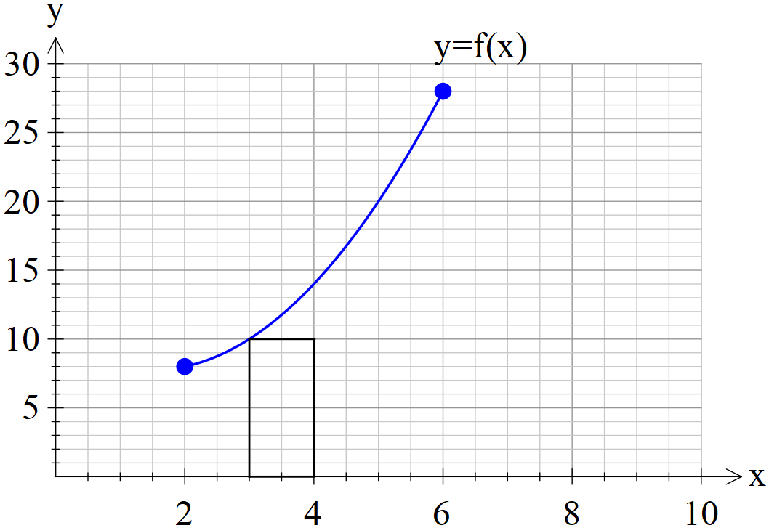

- By using rectangles of width one unit, as shown above, determine a lower estimate for the area under for .

- By using rectangles of width one unit, as shown above, determine an upper estimate for the area under for .

- Determine a better approximation for the area under for .

- Describe two different methods to improve the approximation for the area under for .

Q4 (3.2.18-3.2.17) (3 & 2 = 5 marks)

An oil tank is drained of oil such that if of oil in the tank seconds after draining commences is described by .
The initially full tank is emptied in 2 mins.
- How much oil was in the full tank? (nearest kL)

- How much oil was drained from the tank in the fifth second, nearest kL.

Q5 (3.2.11-3.2.14) (2, 2 & 2 = 6 marks)
Consider a function which is only defined for with
It is known that for and for .
Determine.

- The area between and the x axes for .

Q6 (3.2.20) (4 marks)
Determine to two decimal places the area between the curves and .
(Hint- Sketch the curves first on your classpad)

Q7 (3.2.16) (2 & 2 = 4 marks)
Consider
Determine.

Q8 (3.1.4) (4 marks)
The instantaneous rate of decline in the number of kangaroos on a particular park is 30% of the population per year. If there were 12 050 kangaroos on the park 3 years ago, how many will be on the park in four years from now

Q9 (3.2.6) (2 & 4 =6 marks)
- Determine .

- Using your result from part (a) and without using your classpad determine .

Working out space

Working out space

